Zoe Boyle

Lab 8

Lab time: 5pm-5:50p

1. 
2. 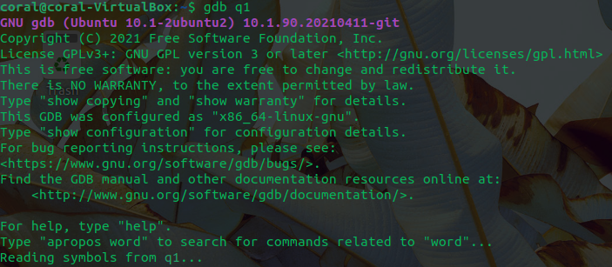
3. 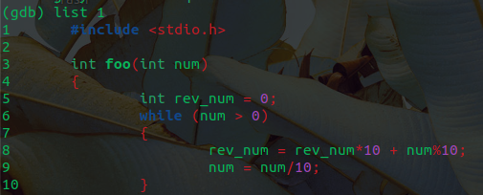
4. Break 6



1. Run

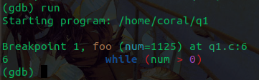

1. 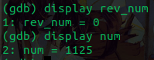

|  | 1st | 2nd | 3rd | 4th |
| --- | --- | --- | --- | --- |
| num | 112 | 11 | 1 | 0 |
| rev_num | 5 | 52 | 521 | 5211 |

1. 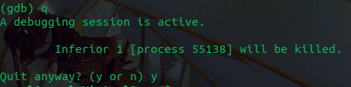
2. The function foo takes an input num, and reverses it by taking the remainder when divided by 10 and adding it to rev_num

Part 2

Line 6- set a value to letters; int letters = 0;

Line 7- set a value to words; int words =0;

Line 11 - changed /n to ‘\n’

Line 13 - space not initialized , initialized it with the other variables

Line 22- expected a float and the input was an integer; changed to (double) letters/words